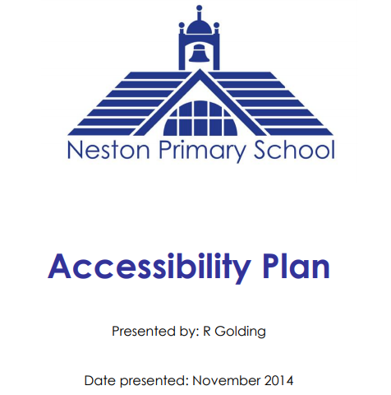
Approved by Governors and staff
Reviewed: November 2017
Reviewed: November 2020
Review date: November 2023

Signed ____________________________________
Chair of Governors

Accessibility Plan
At Neston Primary School, we are committed to ensuring the equality of education and opportunity for pupils, staff, governors and parents/carers who are part of our school community. This included people with a disability or have individual needs or are disadvantaged in a way that would prevent full involvement in school life.
We make our best efforts to address the needs of all children, parents, staff and the wider community. We will work with relevant outside agencies who may be able to help us support individuals within the school.
Aims:
- To increase the extent to which all pupils, parents, carer, staff and governors can participate in the school curriculum and the full life of the school.
- Improve the school environment to increase the extent to which all members of the school community can take advantage of education.
- To make sure we do our best to deliver information to all members of the school community in a way they can access.
- We will consider the needs of members of the school community when planning and undertaking future developments, improvements or refurbishments of the site.
The following table shows area for further development and how the school will address them. This plan sets out further proposals for the school to increase access to education or usage. These points will feed into the SSDP.
Priority target | Success Criteria | Timescale | Cost | Responsibility of
Increase the extent to which pupils can participate in the school curriculum | Staff aware of individual needs and match lessons to the needs of all children | Ongoing | School budget | All staff
 | Pupils with parents on low income are not excluded from school activities |  | PP +school  budget | All staff
 | Effective use of equipment to promote learning where appropriate eg sloping desks, left handed equipment
 | Curriculum planning – adapted to meet the needs of individuals and their specific learning styles
 | School visits are accessible for all pupils regardless of finance, medical conditions, anxiety… |  |  | EVC and all staff
 | Improve the physical environment – where possible we will consider the needs of all users |  |  | SMO
Encouragement of parents/carers to claim FSM | Everyone who is entitled to FSM receives them | On going |  | Admin staff in newsletters and in aware of changes in circumstance – assisted by all staff
Parents will feel included in their child’s education | Provide suitable clear print for parents/carers – avoid ‘teacher speak’, read letters to parents who have reading difficulties |  |  | All staff
 | Mentors and Admin staff will support parents/carers with completing forms
 | To present information to all parents – bumped head notes, letters translated into home language of pupils in school (Spanish, Chinese, Polish etc)  Electronic communication with parents/carers |  | EAL support TA  Admin | TA with language skills  Ensure contact details are up to date and those with parental responsibility receive relevant information

Appendix A: Accessibility to the Building
From September 2002, the Governing Body must fulfil three key duties towards disabled people as stated in the SEN and disability Discrimination Act (DDA) 1995 part 4.
- Not to treat pupils less favourably for a reason related to their disability
- To make reasonable adjustments for disabled pupils, so that they are not at a substantial disadvantage
- To plan an increase access to education for all pupils
Disability as defined by the DDA is:
A person has a disability is he or she has a physical or mental impairment that has a substantial and long-term adverse effect on his/her ability to carry out normal day-to-day activities.

Due to being on a sloping site and the age of the building, Neston Primary School is not conducive to ease of access for disabled people. There are a number of sets of stairs – one from entrance hall to yard door, one from infant door to yard and one set to get to the upper KS2 classrooms. In recent years, the access to the building has been improved with the addition of ramps and accessible toilets.

