**Reception and KS1 English overview**

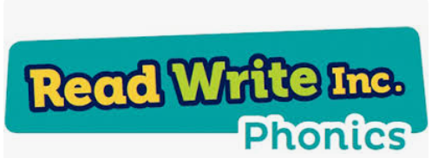**Phonics**

The teaching of phonics is of a high priority at Neston, as it provides the foundations of learning to make the development into fluent reading and writing easier. We use a programme called ***Read Write Inc*.** to teach our children phonics. Most children complete the programme in Year 2.

* Phonics teaching starts in Reception in week 2 of the Autumn term to ensure they make a strong start
* Phonics is taught daily in Reception and Year 1
* In Y2, phonic lessons are taught daily to children where appropriate
* Children’s phonic ability is assessed every half term and those who need support, are given small group or individual support

**Reading**

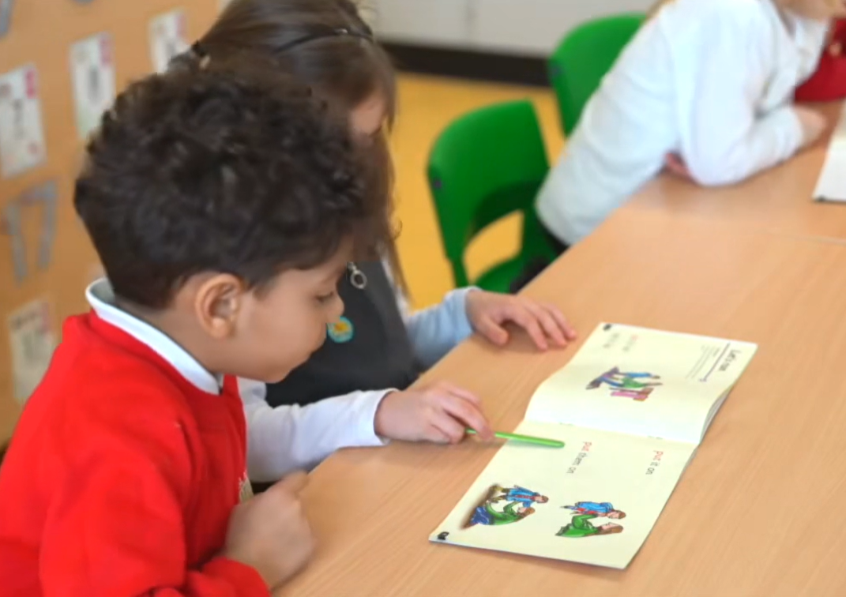 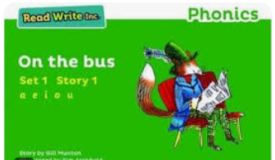

Every child deserves success right from the start. We know that the sooner children learn to read, the greater their success at school. This is why we put reading at the heart of what we do. In Reception and KS1, children read every day. They read phonically decodable books until they finish the *Read Write Inc.* programme. Then they move onto book banded books. During the reading sessions children:

* Apply their phonic and sight vocabulary knowledge (red and green words)
* Learn good reading behaviours e.g. turning the pages, reading with their eyes
* Practise reading texts with increased reading fluency across the week
* In Year 2, in the spring term, children start the **Pathways to Read** programme, which gives the children the opportunity to study a whole class reading text. During these sessions they participate in fluency practice and a variety of reading activities, allowing them to enhance their vocabulary, make predictions, retrieve information and respond effectively to the text.

We run parent workshops in Reception and KS1 to support parents with phonics and early reading to support their child at home.

**Writing**

In Reception and KS1, we focus on building essential skills like handwriting, spelling and sentence construction. Pupils practice these every day. We use **Read Write Inc**. to teach handwriting and spelling. In Year 2, the pupils move onto the **Pathways to Spell** programme.

We also follow **Pathways to Write**. This is based on half termly, ‘inspirational’ core texts to engage students, provide high quality literature models and writing opportunities for a range of genres. We believe children should have plentiful opportunities to practise writing, across genres. Therefore, in KS1, each half term children write narratives, letters, recounts, instructions and reports.

